CICIL Connection Center April 2025 Calendar of Activities
Monday | Tuesday | Wednesday | Thursday | Friday
 | 1. Open 12 PM to 4 PM  You-Choose-Day  Tuesday with Jenna & Larry | 2.  1 PM: Game Day with Larry & Amy | 3.  2 PM: Meditation with Evan | 4.  1 PM: Peer Group with Jenna  2 PM: Movie Day
7.  1 PM: Peer Group with Riley  2 PM: Art Class with DM Art Center | 8.  You-Choose-Day  Tuesday with Jenna & Larry | 9.  1 PM: Adaptive Fitness with Abi  1:30 PM Game Day with Larry & Amy | 10.  2 PM: Meditation with Evan | 11.  1 PM: Peer Group with Jenna  2 PM: Accessible Yoga w/  Peaceful Pactice Yoga
14.  1 PM: Peer Group with Riley  2 PM: Art Class with DM Art Center | 15.  You-Choose-Day  Tuesday with Jenna & Larry | 16.  1 PM: Adaptive Fitness with Abi  1:30 PM Game Day with Larry & Amy | 17.  10 AM-12PM: DART How-to-Ride Training  2 PM: Meditation with Evan | 18.  11 AM-2:30 PM: Bowling at Gameday Lanes
21.  1 PM: Peer Group with Riley  2 PM: Art Class with DM Art Center | 22.  1 PM: Northside Library Outing | 23.  1 PM: Adaptive Fitness with Abi  1:30 PM Game Day with Larry & Amy | 24.  2 PM: Meditation with Evan | 25.  1 PM: Peer Group with Jenna  2 PM: Movie Day
28.  1 PM: Peer Group with Riley | 29.  You-Choose-Day  Tuesday with Jenna & Larry | 30.  11:30 AM: Lunch at Coney Island  12:30-2:30 PM: Moberg Art Gallery Outing |  | 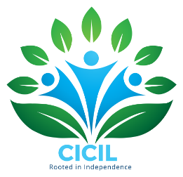
*Follow Central Iowa Center for Independent Living on Facebook for Calendar Updates + Inclement Weather Closings

